**ANGULAR PROJECT   
IPL TEAMS MESSAGING WEBSITE**

STEP 1: COMPONENTS CREATION:

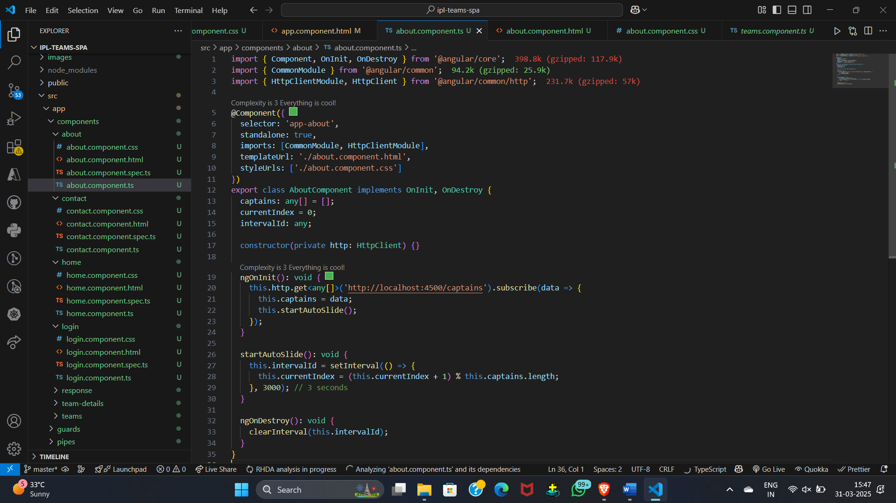

STEP 2: API CREATION (JSON FILE)

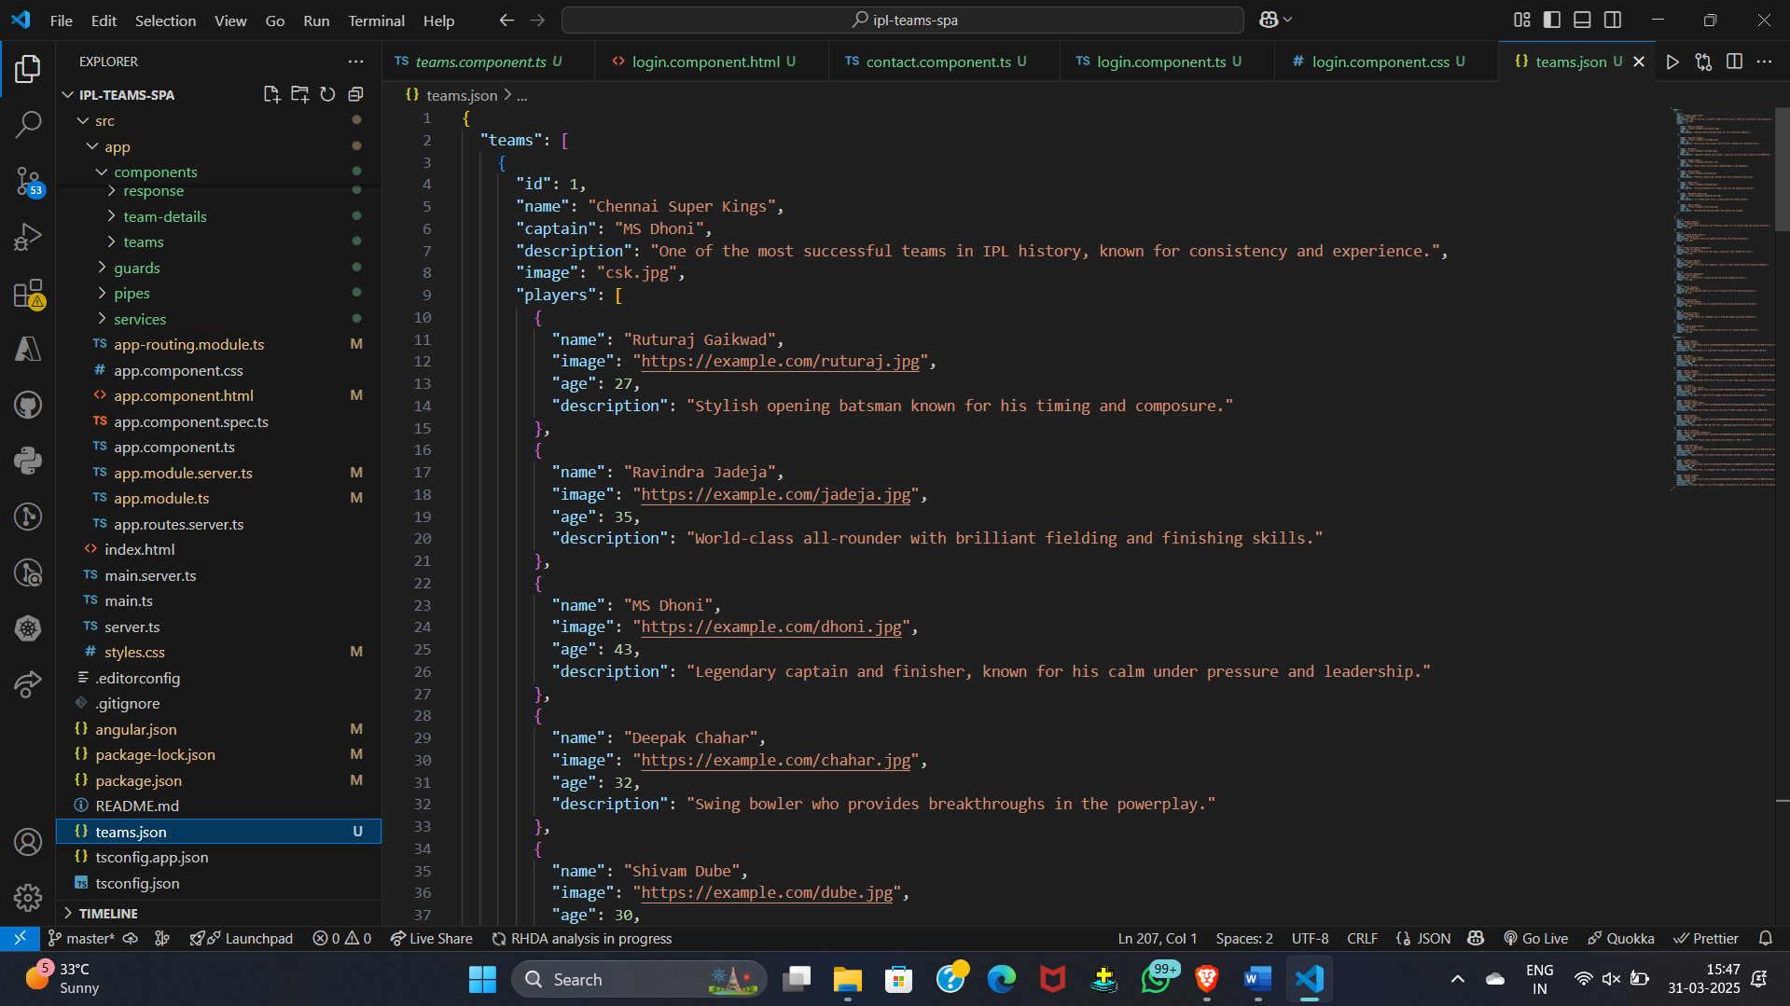

STEP 3: AUTH GUARD

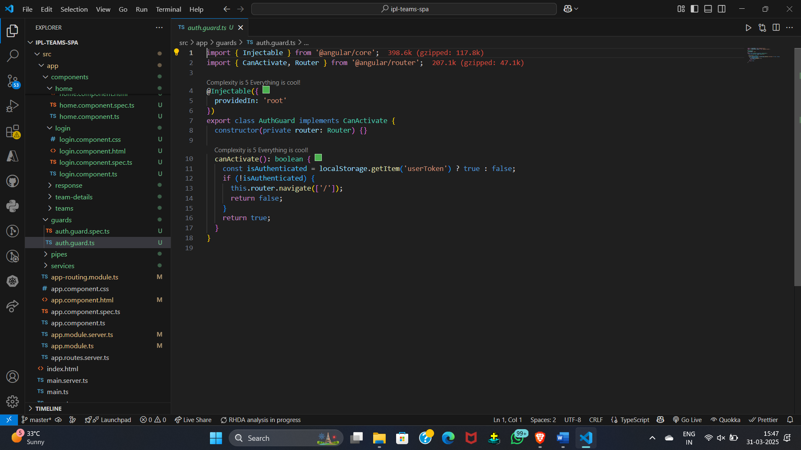

STEP 4: PIPES

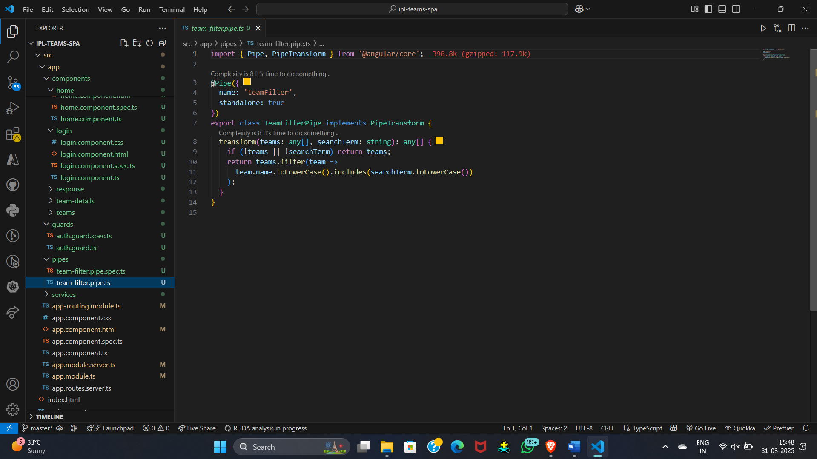

**OUTPUT:**

**HOME**

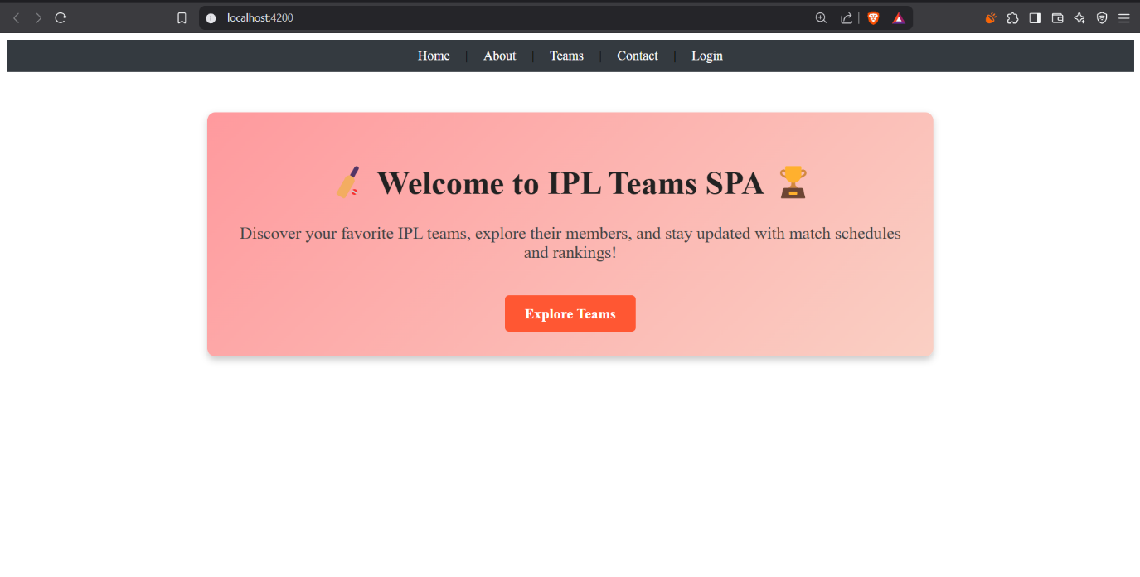

ABOUT PAGE

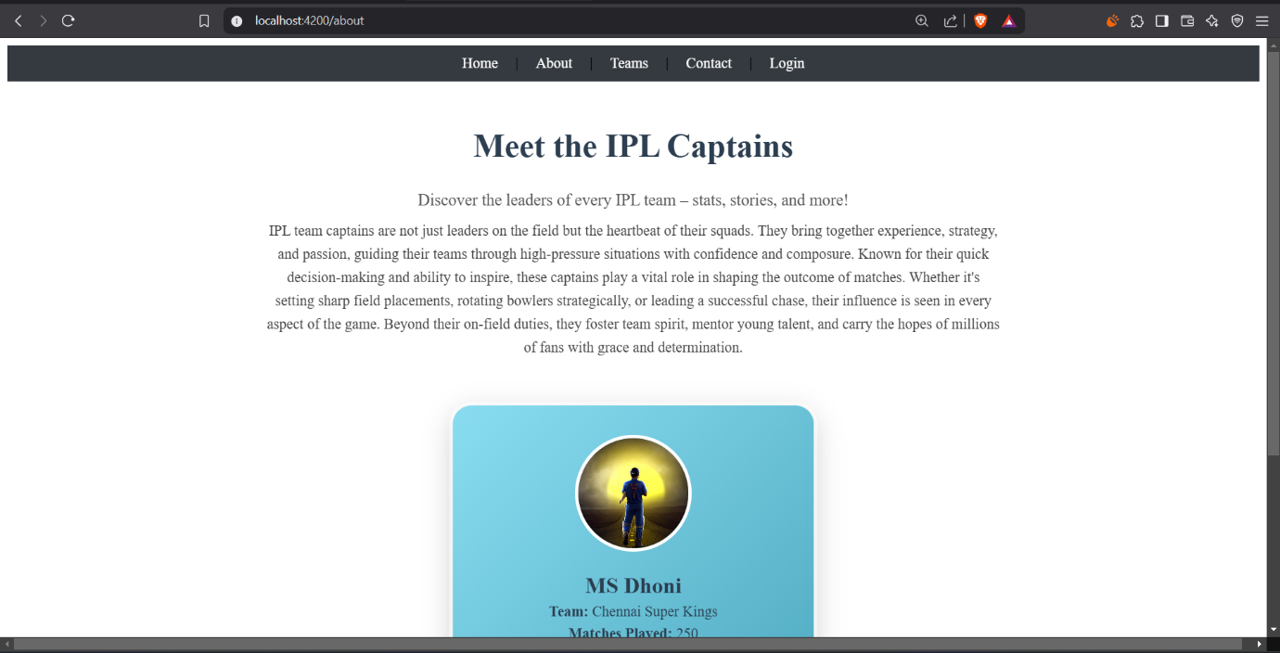

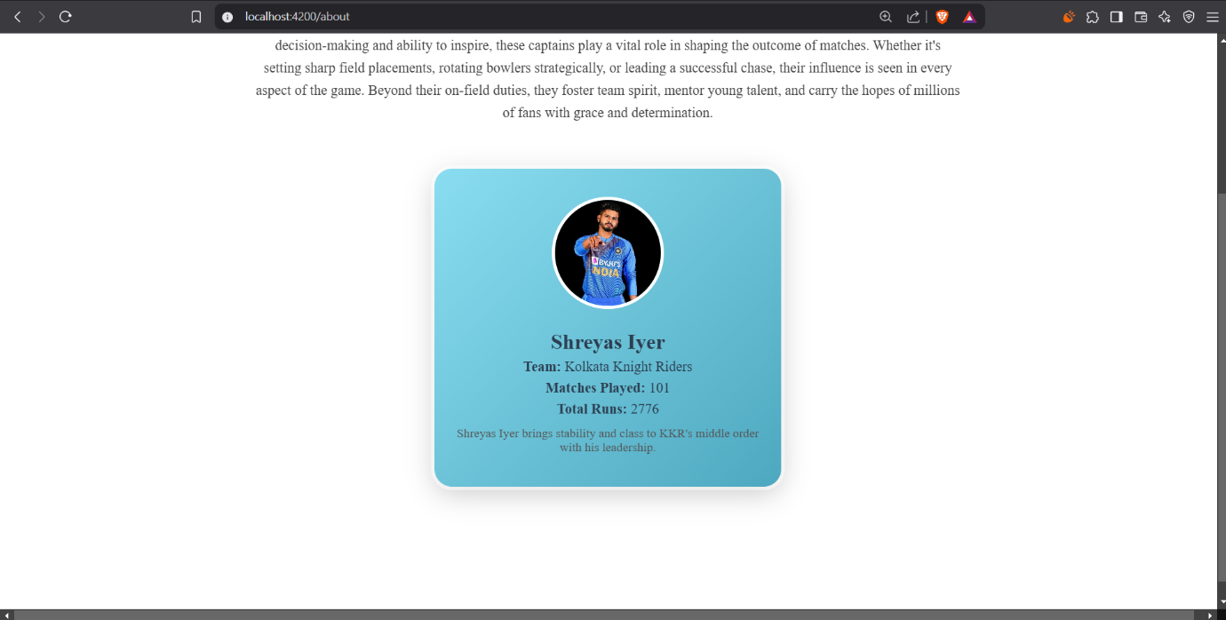

I implemented a **card carousel display** on the About page in my Angular project to showcase each **IPL team captain's details**. This feature allows users to smoothly navigate through captain profiles, displaying their **name, image, age, and description** in an interactive and visually appealing manner. The carousel enhances user engagement by presenting captain details in a structured and dynamic format.

**TEAMS PAGE**

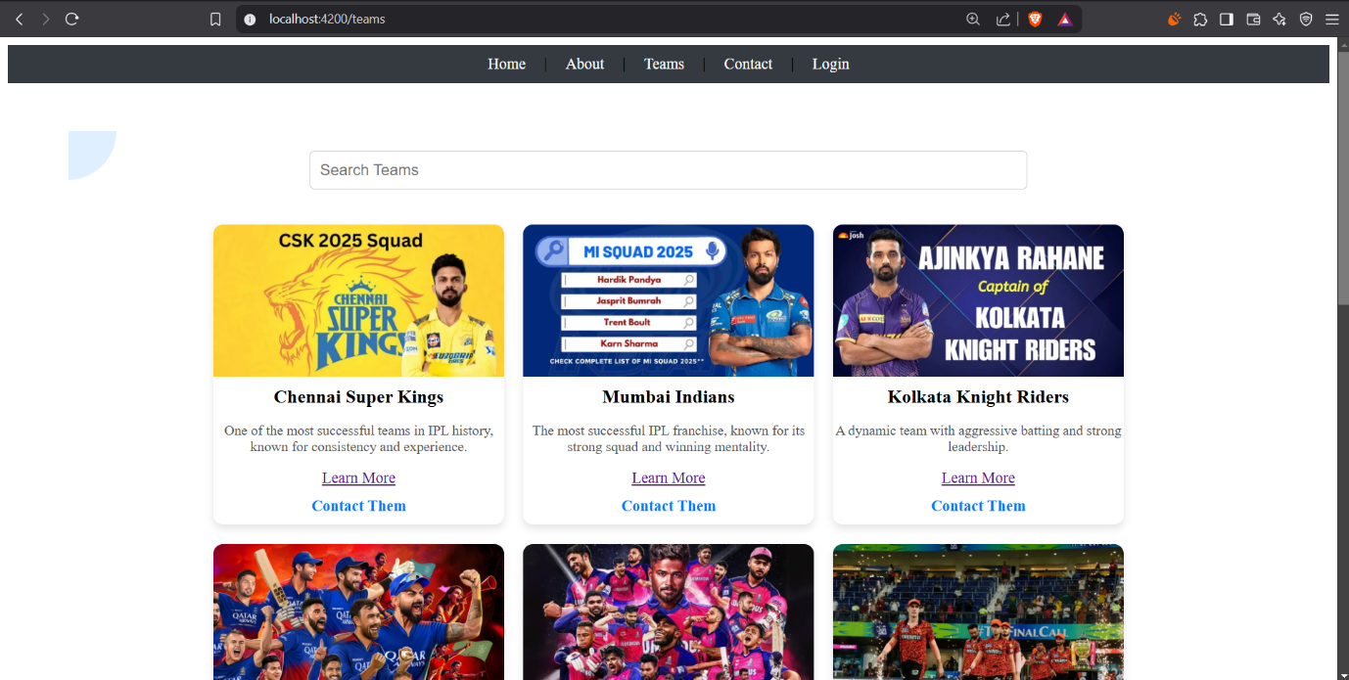

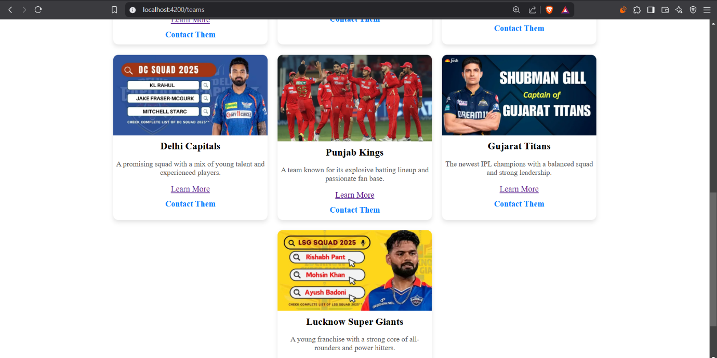

In teams page, I have displayed all the current IPL teams along with their captain’s images.

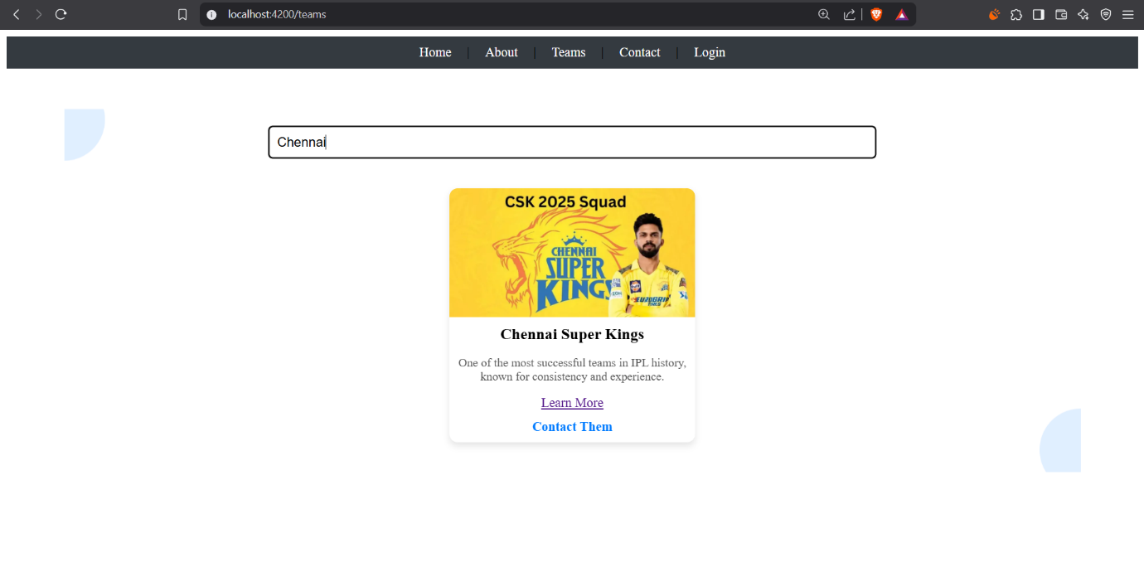

I used **Angular pipes** to filter the search results on the **Teams page** based on the user's search term. This allows users to quickly find specific teams by dynamically updating the displayed results as they type. The pipe efficiently filters the team data, enhancing the search experience with a smooth and responsive interface  
  
also we can use contact them button for navigating to contact us page.  
  
learn more button will navigate you to about page to know about the captains.

CONTACT US PAGE

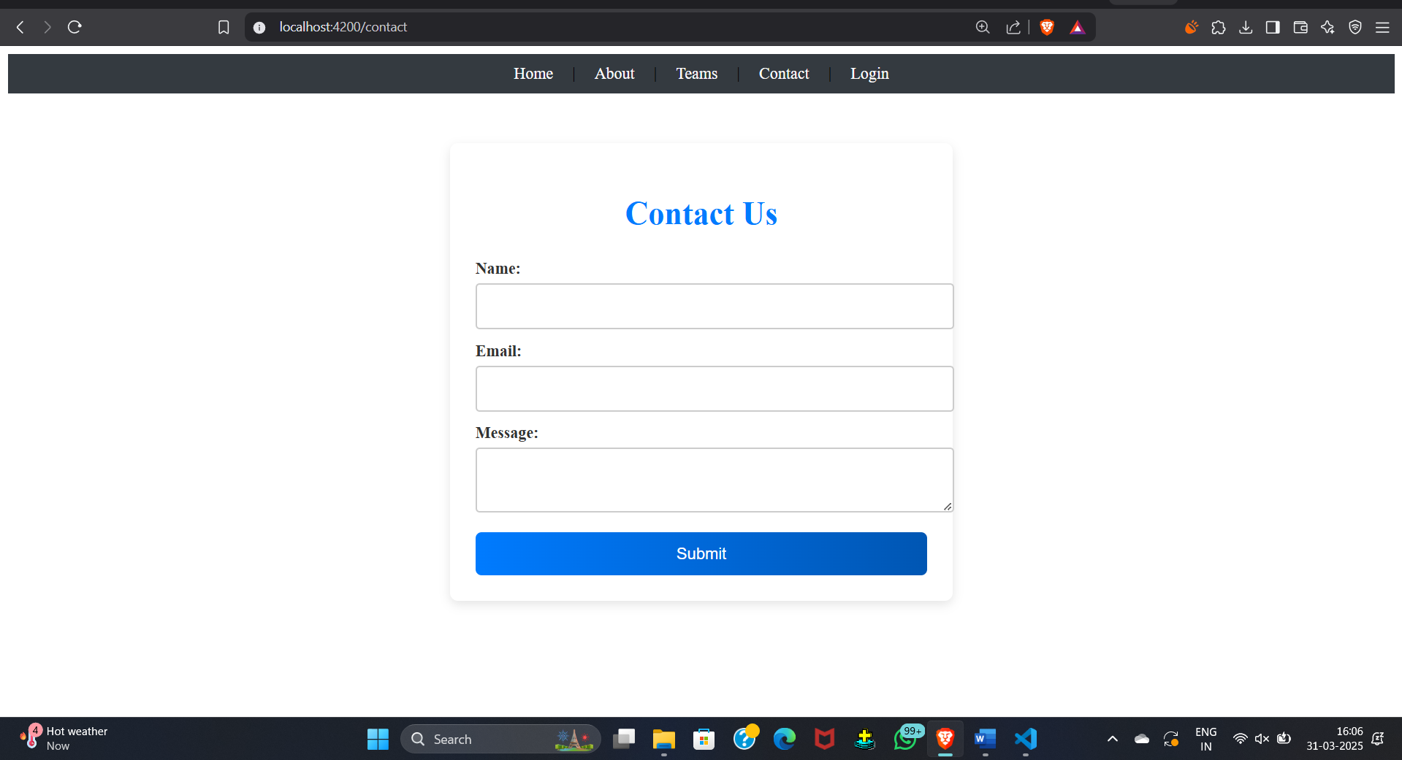

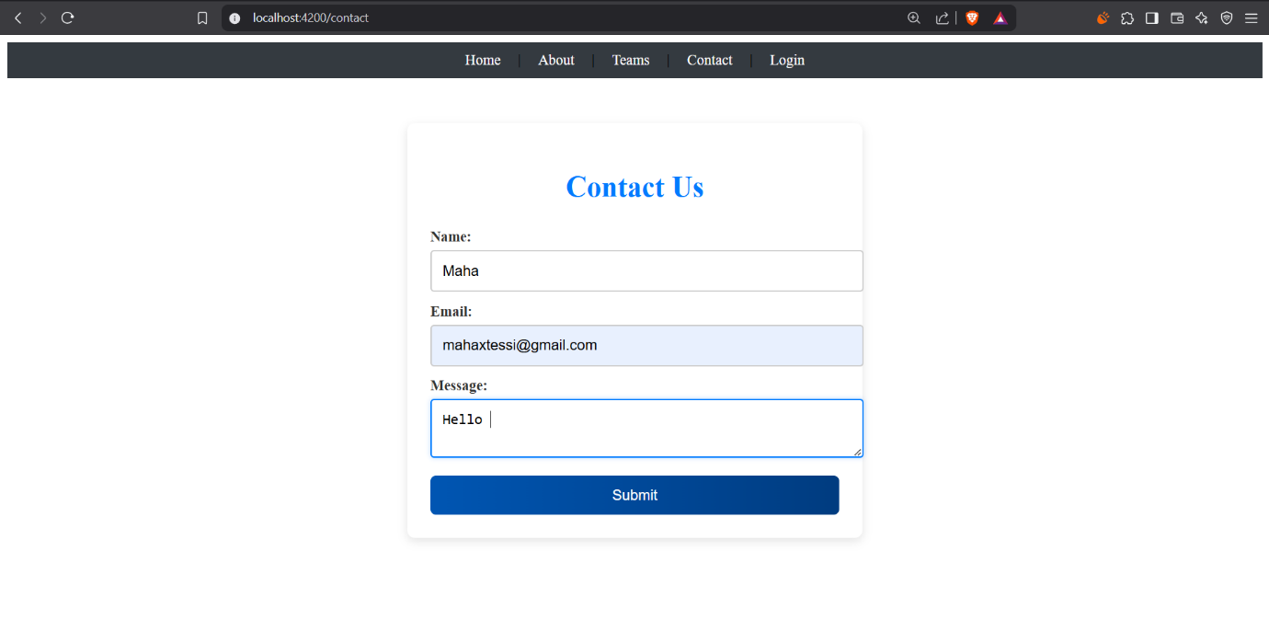

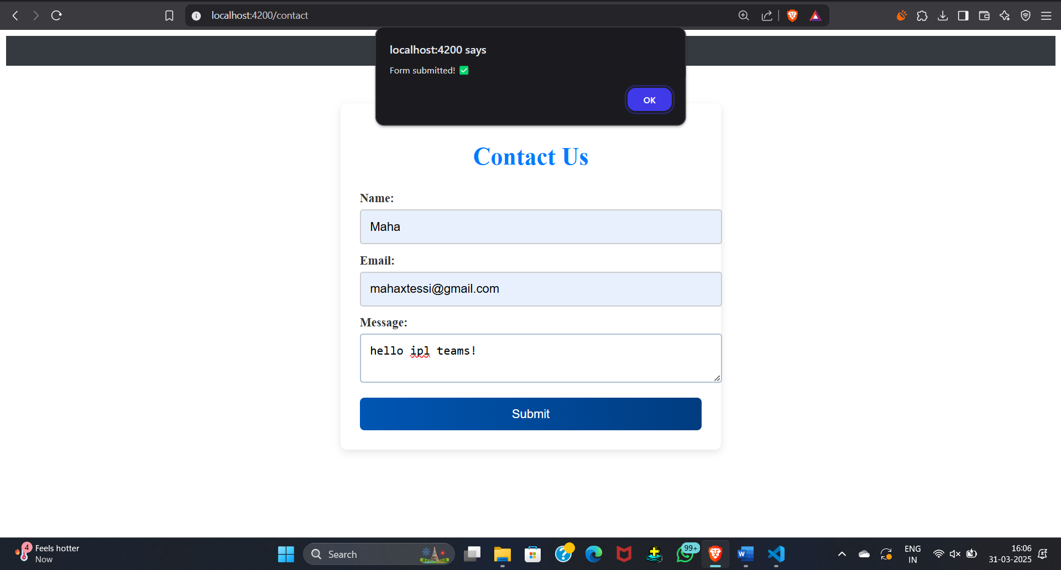

After submitting, if the form is submitted correctly, the page will alert “Form submitted successfully”.

Since it is basically an anonymous messaging platform for all the ipl fans. They can send messages to their favourite ipl teams. Only the admin of the page can view the messages.

When normally viewing the admin page, It will ask for user mail and password.

Only when the details are entered correctly, they can view the messages.

LOGIN PAGE FOR ADMIN :

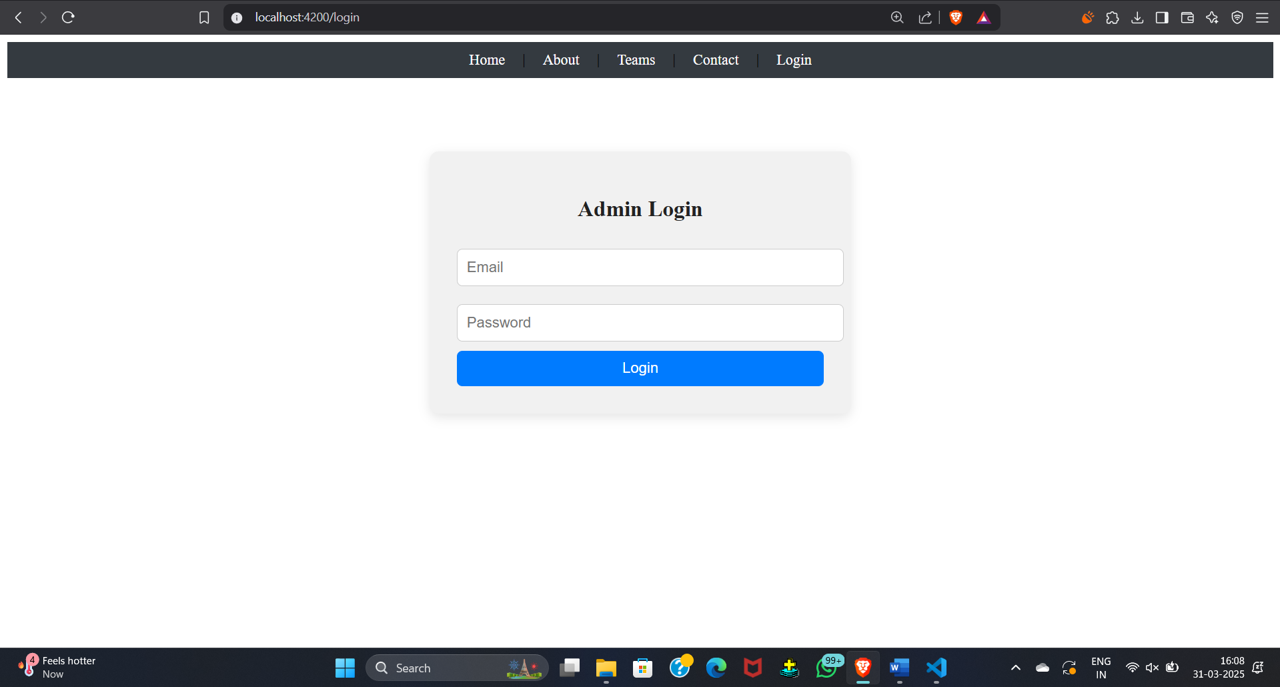

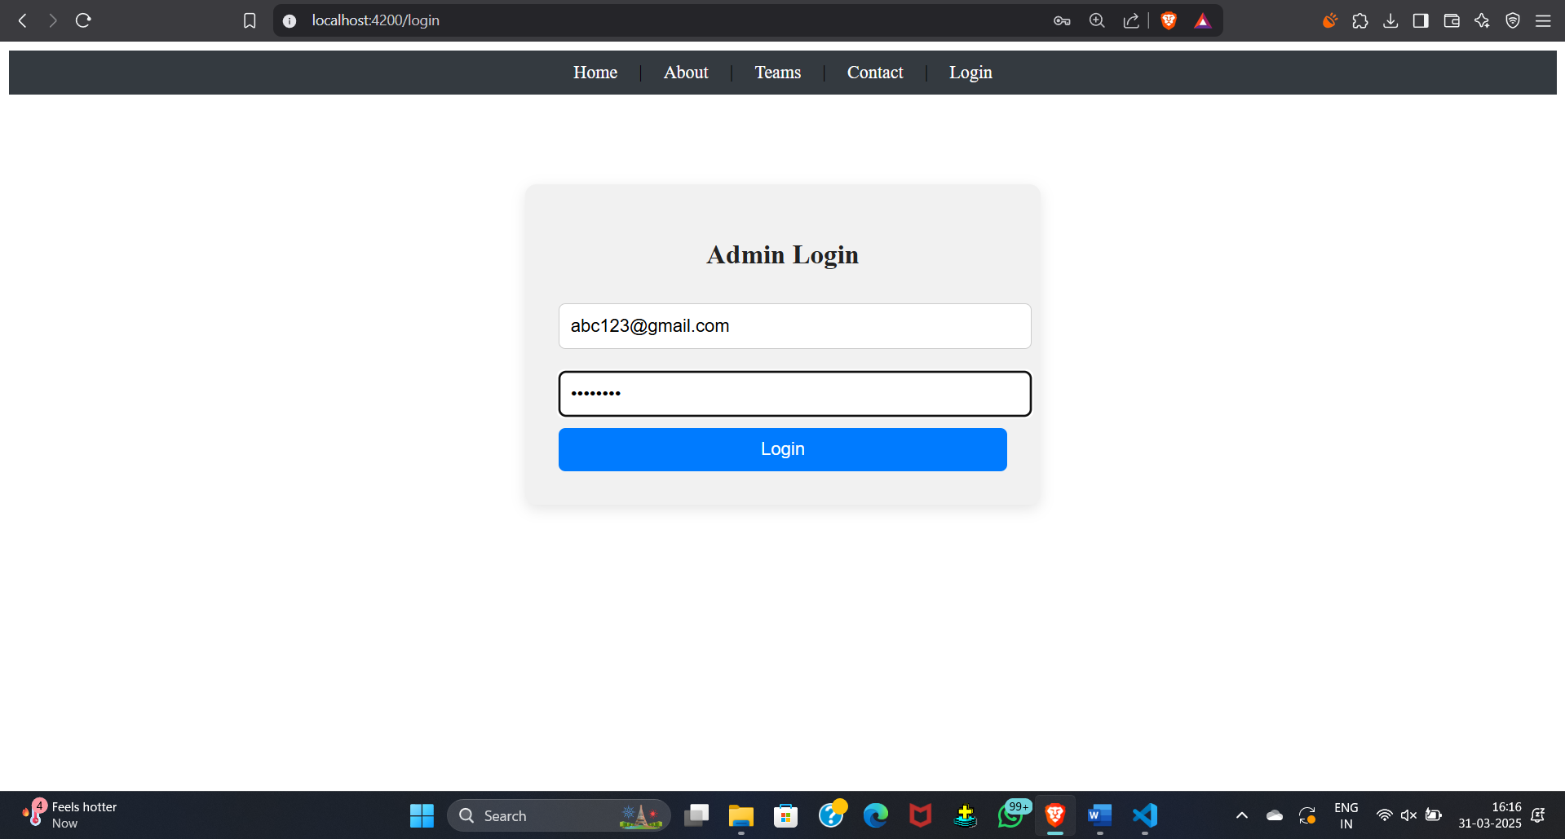

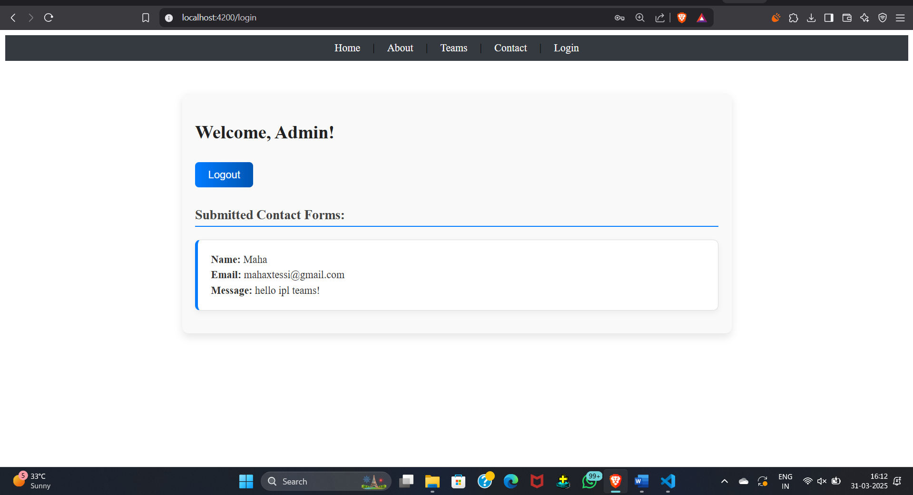

**CONCLUSION**

* The IPL Teams Angular Website is a Single Page Application (SPA) built using Angular, designed to provide a seamless experience for cricket fans.
* It features an intuitive interface for exploring IPL teams, viewing player details, checking match schedules, and engaging with team statistics.
* The application utilizes Angular Pipes for data formatting and filtering, making it easier for users to search for teams, players, and match details.
* The Auth Guard feature ensures that only authenticated users can access certain sections, such as team discussions and fan forums.
* The Home Page highlights featured teams and quick navigation links, while the Teams Page lists all participating teams with filtering options based on performance, ranking, and squad composition.
* The Team Detail Page showcases in-depth information about each team, including player rosters, coaching staff, and recent match highlights.
* Fans can submit their opinions, and a custom pipe formats comment timestamps for better readability.
* The Contact Us page provides a way to reach support for inquiries and fan engagement.
* The app uses Services with Observables to dynamically fetch team and match data, ensuring real-time updates.
* Future enhancements could include live score updates, match predictions, ticket booking integration, and an interactive fan zone to enhance user engagement.